Project Two

Michael King
SNHU
CS-320
Kevin Tepas
12/14/2025

Testing Approach
I think the way I conducted my tests was mainly in accordance with the software requirements. My testing approach consists of breaking down the list of requirements into smaller subdivisions that were more manageable, and then I figured out how to create my test cases. I used the provided module resources to do this. One specific instance of this method is the Appointment Test Java file, in which I tested the three different scenarios of an appointment ID: a valid, null, and invalid appointment ID.
AppointmentTest.java (Project One)
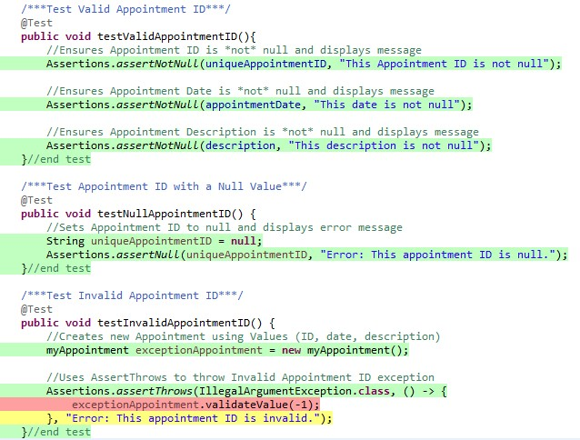
In addition, I applied the same scenarios for the appointment name and appointment description. By carrying out this comprehensive testing plan, I was able to provide evidence that all the customer’s requirements in this project have been fulfilled.

JUnit Test Quality
I believe the overall quality of my tests for this project was satisfactory as they covered a large percentage of the code. The coverage is shown below.
Project One Coverage
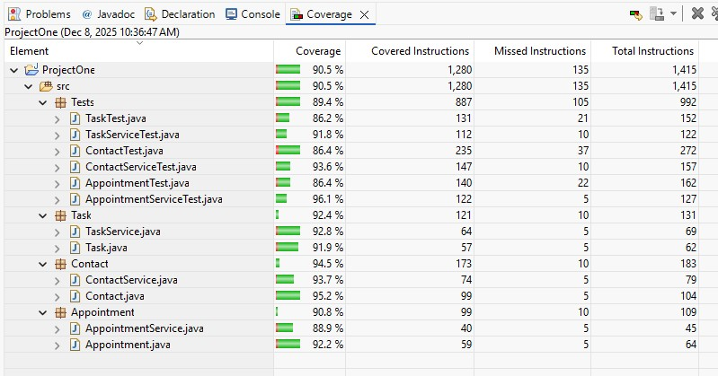
I have brought about the code correctness by means of test cases which I have implemented for every test case in accordance with the criteria in the rubric and those covered by the requirements. Thus, I have facilitated the effective testing through checking the work and making sure that it is aligned with the requirements. As an example, shown below, I made sure the setters for the Appointment Date and the Appointment Description had all of their branches covered.

Appointment.java (Project One)
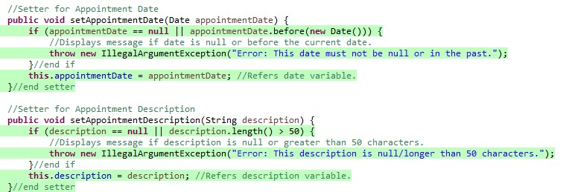
I did this by improving the test cases for those two variables as illustrated below.
AppointmentTest.java (Project One)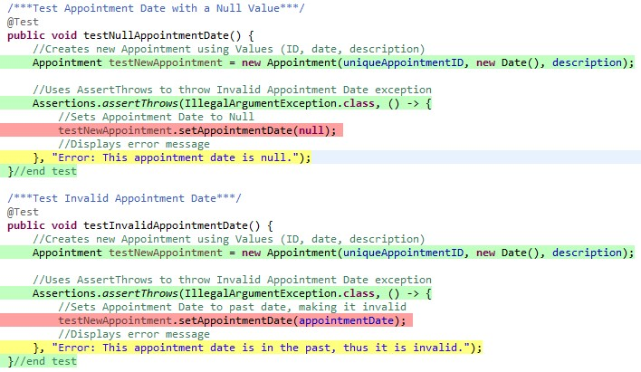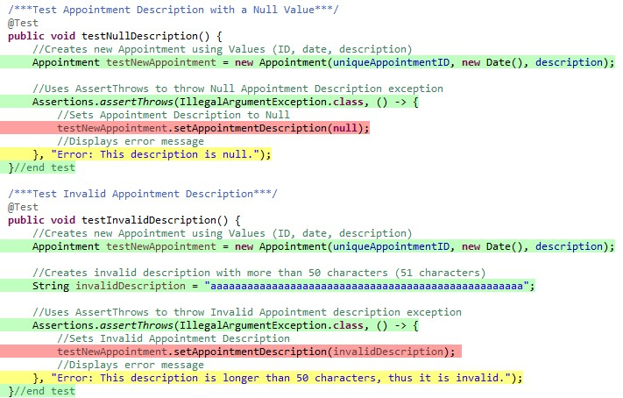

Technically Sound Code
I made certain that my code was technically sound by adding variables for the task values, such as the Appointment ID, name, and description, at the top of the Appointment Test Java file. As an illustration, shown below, I included the Before Each annotation to ensure the variables are executed before the testing method. By doing this, I could verify that the coverage tests are consistent and accurate.
AppointmentTest.java (Project One)
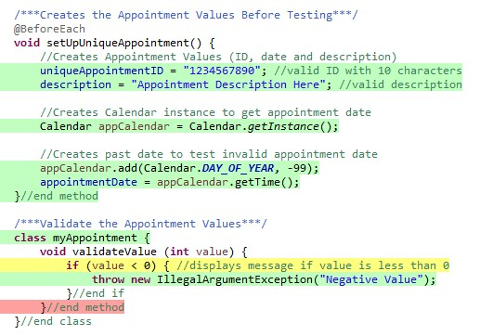
To check the correctness of the task values, I characterized functional tests with the Test annotation which is displayed before each method as shown below. To test a valid Appointment ID, I included the Assert Not Null function to declare it as not null. Likewise, for a null Appointment ID, I included the Assert Null function. This verification process provides proper testing for all possible outcomes of the Appointment ID, name, and description.

AppointmentTest.java (Project One)
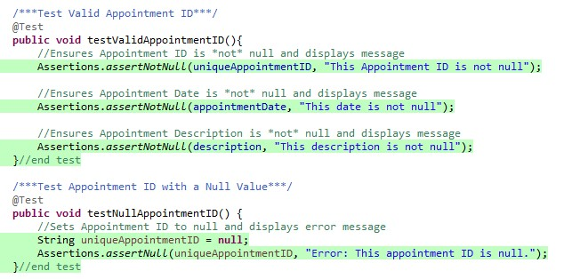
I applied the same methodologies for the Contact Test and Task Test Java files. This approach ensured that the code maintained an efficient standard of technical soundness, allowing me to build more seamless code and provide greater code quality and integrity of this project.

Efficient Code
To make my code efficient, I applied a hash map for storing the Task, Contact, and Appointment objects, with which I have been able to test the methods of adding, deleting, and updating contacts, tasks and appointments, as illustrated below.
ContactService.java (Adding a New Contact)
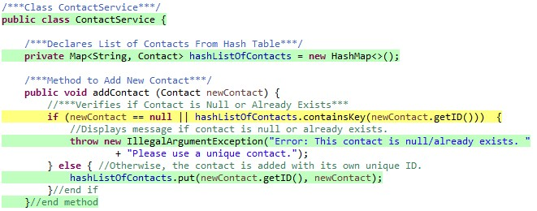
TaskService.java (Adding a New Task)
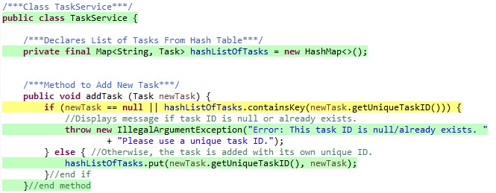
AppointmentService.java (Adding a New Appointment)
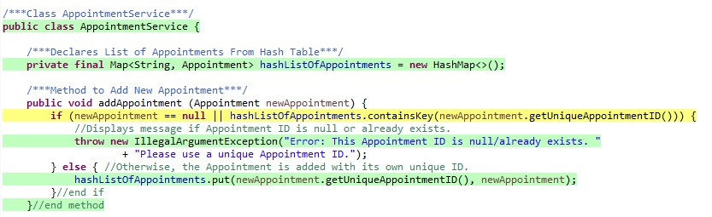
I accomplished this through the Contains Key procedure, which can, when used, quickly find a contact, task, or appointment in a hash map. By utilizing the power of a hash map, the locating and handling of Appointment, Task, and Contact entities have been very much facilitated. Consequently, the operations like adding, deleting, and updating have become simple and quick at the testing point. My structure gave me the opportunity to check the methods’ correctness and also to be sure that the services were registering accurately in each test case. I used this structure in the Contact Service, Task Service, and Appointment Service Java files, significantly changing the arrangements and the quality of the hash map. The service layer has become more stable and responsive.

Testing Techniques
Throughout this project, I have learned that JUnit testing is efficient because it tests the program in the stages which are less developed, making it especially useful to find bugs quickly. This method has helped me before in the previous modules, so I decided to implement it for the three services in this project. For instance, the code in the Contact Service involved making changes to contacts by adding, removing, or updating them. I employed this method to confirm the code worked and to find any defects. Besides that, I have thought of different ways which can be used for the improvement of the code at various services like code reviews and refactoring. These methods are preceded by initial testing which is used for bug-finding in the code.
Several distinct software techniques were not included in this project. The first one, regression testing, is considered to be the most accurate, as it saves time by using fully automated repeated tests that can be done very quickly. The next method is integration testing, which is far more difficult than regression testing because it requires more thorough and lengthier tests. Lastly, the final method is system testing, which is basically the level of testing where the full functionality of the system is verified (GeeksforGeeks, 2025).
Each of these different testing stages has different functions when guarding the software against bugs. Unit testing is the confirmation of a system’s pieces of code to validate their functionality. Regression testing is the one that makes sure contemporary code changes have not broken the system’s existing functionality. Integration testing is a very important method which is used to check various software modules that are combined. System testing is about the verification of a complete and integrated application, including functional and nonfunctional requirements, to confirm that it is working properly for the users (GeeksforGeeks, 2025).

Mindset
It was very critical to have a careful mindset during the whole project. Grasping the complicated and interconnected nature of the code was instrumental in pinpointing problems that could arise in the front of the line. For instance, during the testing of the Contact Service Java file, I figured out that modifications in the Contact class might result in the Task and Appointment Java files being changed because of common attributes. This recognition resulted in thorough tests which ensured that not only the direct functionalities are tested, but also the interactions between classes.
To reduce bias in my code review, I try hard to be objective in each evaluation, to check logic and structure without any prior assumptions. Such a habit allows me to find code lines that are less familiar, making them hard to find. I also use a clear checklist to consistently follow every code change, allowing me to cover all the aspects of the code. These practical approaches not only elevate the quality of my code but also enable me to build trust with my clients, thereby making certain that the software meets the standards of excellent functionality and safety.
Being disciplined in my commitment to quality is important, as cutting corners can lead to serious code defects and security problems. For instance, for medical software, cutting corners in code could result in a security breach that could make the company liable for expensive legal consequences, apart from the cost of reworking the code to fix the oversight and the loss of reputation with clients due to the lack of quality. My plan to prevent technical debt involves improving the code structure in my projects to increase my confidence.

References
GeeksforGeeks. (2025, July 23). Levels of software testing. GeeksforGeeks. https://www.geeksforgeeks.org/software-testing/levels-of-software-testing/

